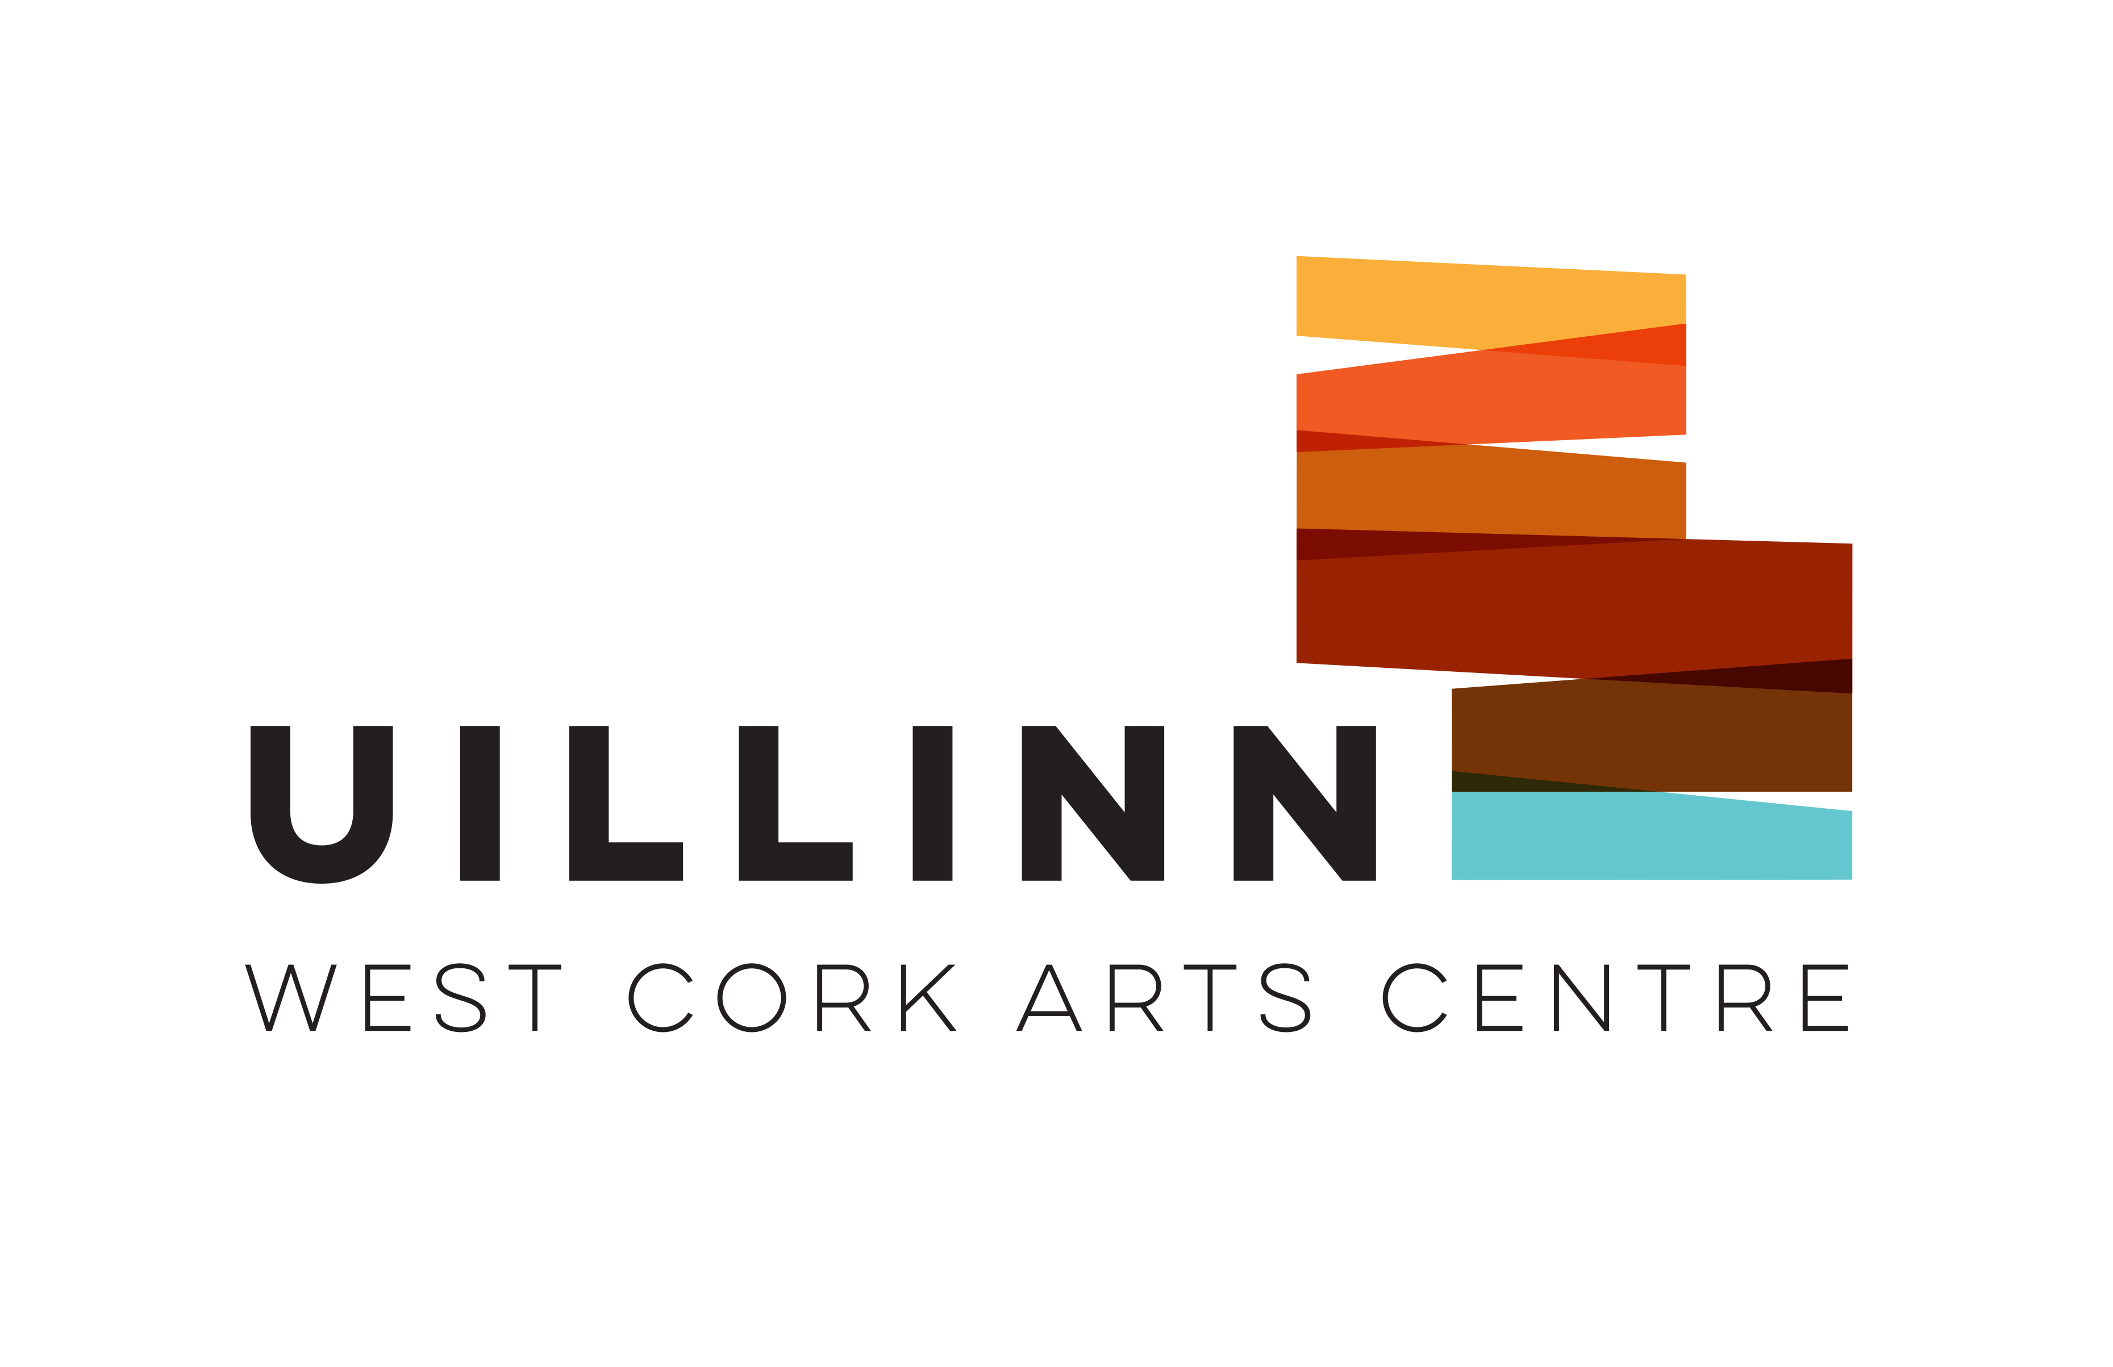
Rusty Frog Youth Theatre
Membership Form (Under 18)

Section A: Member Details

Name
Age: | Gender:
Address:
Home Telephone: | Mobile:

Section B: Parent(s)/Guardian(s) Details

1 Name: | Home Telephone:  Mobile:
2 Name: | Home Telephone:  Mobile:
I (Parent/Guardian) consent to be contacted for the purpose of verifying my identity as parent/guardian of my child. Please tick to consent:
Medical Conditions/Additional Requirements
If you do not have sufficient space to provide full details, please complete the attached Additional Information Sheet. If you answer ‘Yes’ to any of the below, please give details on the form or call 0838278115 by text in confidence.
Please note that information may have to be shared with others in the interest of your child’s welfare. Any information provided will be treated as confidential and managed in line with the youth theatre’s Confidentiality Policy.
1 Does your son/daughter/ward have any additional requirements? e.g. physical disability, learning difficulties or literacy issues  If ‘Yes’, please give details |  | Yes | No
2 Does your son/daughter/ward have any medical conditions of which we should be aware?  If ‘Yes’, please give details |  | Yes | No
3 Have you been advised by your doctor that your son/daughter/ward is in an ‘at-risk’ group in relation to COVID-19?  If yes, please give details and contact 0838278115 by text regarding their safe participation: |  | Yes | No
4 Does your son/daughter/ward have any allergies?  If ‘Yes’, please give details |  | Yes | No
5 Is there any other information we need to be aware of that may impact on your son’s/daughter’s /ward’s participation in youth theatre?  If ‘Yes’, please give details |  | Yes | No

Section C: Parental Consent
I give consent for:
1 My son’s/daughter’s personal data, as provided, to be processed in line with the purposes detailed in the Privacy Statement at the end of this form. | Yes | No
2 My son/daughter to attend weekly drama workshops. | Yes | No
3 Photograph/Video Footage of my son/daughter to be taken during youth theatre events. | Yes | No
4 Photographs/Video Footage including my son/daughter to be used publicly in posters/flyers and/or newspapers for publicity purposes. | Yes | No
5 Photos/Video footage to be stored and used for archival purposes (All photos/video footage will be managed in line with the youth theatre’s Use of Images Policy). | Yes | No
6 First aid/medical assistance to be sought in the case of an emergency. | Yes | No
7 I have informed the youth theatre of relevant information with regard to any medical conditions or additional requirements that relate to my son/daughter/ward through this form or through discussions with a youth theatre leader. | Yes | No
8 I have read the COVID-19 Procedures for Rusty Frog Youth Theatre | Yes | No
9 I have completed the COVID-19 Declaration Form for my son / daughter/ward, and I can confirm that they have no symptoms of COVID-19, are not self-isolating and are not awaiting results of a COVID-19 test. I understand that if there is any change in this status, they cannot attend youth theatre, their GP must be contacted, and they must self-isolate for the required period. | Yes | No
10 I have read the Information Sheet provided by the youth theatre. | Yes | No
11 I have enclosed the membership fee of €50 for term 1. | Yes | No
Signed__________________________________ Date:___________________________
*If you wish to discuss payment, paying by installments, bursaries, or any other matter in relation to the above, please do not hesitate to contact

Section D: Members’ Consent

I give my consent for photos/footage of me to be taken during youth theatre activities and for them to be used for publicity and for the youth theatre archive. | Yes | No
I have read the COVID-19 Procedures for Rusty Frog Youth Theatre | Yes | No
Signed_______________________________ Date:___________________________
Please return to Uillinn: West Cork Arts Centre, Skibbereen, Co.Cork, P81 VW98

Additional Information relating to Medical Conditions or Additional Requirements.

Please note if you would like to discuss any of the information relating to your son’s/daughter’s medical conditions or additional requirements with us, please contact West Cork Arts Centre on 0838278115 by text. We may also contact your for clarification or more information if necessary.

Parental Consent for use of personal data:
Rusty Frog Youth Theatre will use personal data only where consent to do so is affirmative, freely given, specific, informed and unambiguous. The below privacy statement provides information on why we gather and how we will use your son’s / daughter’s personal data.
The Data Protection Contact Person at Rusty Frog Youth Theatre is Justine Foster 0838278115 You can contact this person if you have a question regarding how your son’s/ daughter’s personal data will be processed.

Privacy Statement
The personal data requested in this form is collected solely for the purpose of supporting your son’s/ daughter’s participation in Rusty Frog Youth Theatre.
Data such as contact details will be used to communicate with you and your son/ daughter in relation to your son’s /daughter’s membership of the youth theatre.
Data such as gender and age is used to ensure your son / daughter is assigned to aspects of the youth theatre activities that are age appropriate. It also helps us to make accommodation and other arrangements in the case of trips or residentials your son/ daughter may participate in during their time in membership of the youth theatre.
Details of your son’s /daughter’s age and gender are also provided to funders and Youth Theatre Ireland to generate statistical information but are aggregated with all members and not directly linked to your son/ daughter personally or used to identify your son/daughter to third parties in any way.
Sensitive personal data such as details of medical conditions or other personal needs are collected so that we can ensure the safety and welfare of your son / daughter whilst participating in the youth theatre. Information that is given in this form in relation to being in an ‘at risk’ category for COVID-19 will be used to support a young person’s safe participation in youth theatre activities during the pandemic. The accompanying COVID-19 Declaration Form will be deleted immediately once it has been assessed by youth theatre leaders, has been recorded as being received and any necessary follow-up action has been taken. Rusty Frog Youth Theatre is collecting this sensitive personal data for the purposes of maintaining safety at our youth theatre activities due to the Covid-19 pandemic. The legal basis for collecting this data is based on vital public health interests and maintaining occupational health.

Your son’s/ daughter’s personal data will only be shared with those who need to know it, and only disclosed to a third party in the case of an emergency such as if they become ill or have an accident that requires medical attention.
Images including video will be collected for the purpose of promoting and documenting the activities of Rusty Frog Youth Theatre and for archival purposes. Images will be managed safely in line with our Use of Images Policy. The promotion of our productions and other events requires that on occasions images will be used in the public domain.
Rusty Frog Youth Theatre will retain personal data on file for a period of the duration of the membership and for 1 year after, when it will be destroyed.
Personal data in the form of photographic images and video will be retained permanently or until such time they become obsolete for the purpose of promoting and documenting the activities of Rusty Frog Youth Theatre.

Your rights:
Rusty Frog Youth Theatre is committed to upholding yours and your son’s /daughter’s rights as provided for by the General Data Protection Regulation (GDPR) including:
- The right to be informed about how we will use your personal data.
- The right of access to a copy of the personal data we hold and information on how we process it.
- The right to have incorrect or incomplete personal data corrected.
- The ‘right to be forgotten’ and have personal data deleted if you so request.
- The right to restrict how we process your personal data.
- The right to object to the processing of your personal data.
- The right to data portability

To be completed by Parent/ Guardian
I consent to the use of the personal data provided for the purposes outlined in the above Privacy Statement.
Signed: __________________________​Date: _______________

